H3 HOMEBUYERS
Sell Your House Fast In Ohio

STANDARD OPERATING PROCEDURE
Montgomery County, Ohio
First to Market (FTM) Probate Lead Sourcing & Extraction

SOP ID | H3-SOP-MCO-002
Department | Acquisitions / Lead Generation
County | Montgomery County, Ohio
Portal | https://go.mcohio.org/applications/probate/prodcfm/casesearchx.cfm
Version | 1.0
Effective Date | April 2026
Prepared By | H3 Homebuyers Operations

1. Purpose

This Standard Operating Procedure (SOP) defines the end-to-end process for sourcing, extracting, and organizing FTM for probate leads from Montgomery County, Ohio using the Montgomery County Courts Online case search portal.

2. Scope

This SOP applies to all H3 Homebuyers Acquisitions team members responsible for lead generation from court-filed Probate actions. It covers:
- Navigating the Montgomery County Courts Online portal to search Probate filings
- Opening each case, navigating to the docket, and viewing relevant entries
- Manually obtaining relevant information

3. Tool/Resource Required

Tool / Resource | Details
Montgomery County Courts Online | https://pro.mcohio.org — Court case search portal

4. Step-by-Step Procedure

1 | Navigate to the Portal Open your browser and go directly to: https://go.mcohio.org/applications/probate/prodcfm/casesearchx.cfm
2 | Select Case Search On the homepage, just enter the Calendar Year and leave the Case Number field blank, and click Search
3 | Review Search Results A list of cases will appear with the most recent one at the bottom of the page. Note that each case appears only once in the Search Results page.
4 | Open Each Case & Record the Case Information Open each case number on another tab and manually extract the following data, to wit:  - Decedent's Name  - Date of Death  - Case Number  - Case Type  - Fiduciary’s Name and Address  - Co- Fiduciary’s Name and Address, if there’s any
5 | Extract the Fiduciary’s Phone Number and Email Address Click on the Docket entries by clicking on this    Open the PDF file uploaded that labeled as “Application for Authority to Administer Estate”, “Application for Summary Release”, “Application for Release of Administration”, “Application for Transfer of Certificate”, “Fiduciary Bond”, or “Notice of Will for Probate”, whichever is applicable on each case.  Look for the Applicant’s name, address, phone number, and email address stated on that Court-admitted Application, usually at the bottom of the last page; may be typed or hand-written; and manually enter the phone number to the spreadsheet while ensuring the name and address stated thereat matches the information obtained from Step 4
6 | Extract the Subject Property:  - If the case type is “WITHOUT WILL”, open the same PDF FILE AS ABOVE.  The subject property is usually stated on the top most part of the first page, after the Decedent’s name and Date of Death.  - If the case type is “WITH WILL”, open the specific PDF file “APPLICATION FOR AUTHORITY TO ADMINISTER ESTATE”
7 | Repeat for All Cases Work through the entire list in your search results, opening each case, going to the case details and docket entries, and extracting relevant information from the appropriate PDF file.

5. Quality Control Checklist

Before closing out a lead pull session, verify each item below:

- In the event that the Fiduciary’s Name, Address, and Phone Number on the Case Details Page (in Step 4) is inconsistent with the information as seen on the PDF file (in Step 5), the latter shall prevail.
- Any cases with missing data or no dockets uploaded yet are flagged for re-extraction.

6. Recommended Pull Frequency

Frequency | Recommendation
Daily (Recommended) | Pull new filings everyday, ideally around 22:00 to 02:00 (the following the day) Specifically for Montgomery county, the Fiduciary’s phone number and Subject Property are not available yet but the basic case information are. Hence, to provide fresh, first-to-market leads before competitors, document this on a daily basis and revisit when the portal has all the pdf’s uploaded.
Weekly | Necessary to review previous leads with incomplete information
Monthly | Considered as Ad-Hoc / Catch-Up to run a historical pull when first setting up this workflow to build an initial pipeline.

7. Troubleshooting

Issue | Resolution
Confirm Form Resubmission | Reload the page
Upon clicking Docket entries,  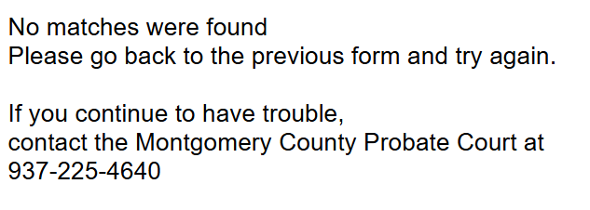 | Refresh the search results page, re-open the case information, and click access the docket entries again.  If the error still shows, entries have not been uploaded on the portal yet and needs to be extracted at a later time

8. Revision History

Version | Date | Author | Summary of Changes
1.0 | April 2026 | H3 Homebuyers Operations | Initial release
Document Approval
Prepared By | Reviewed By | Approved By
Name: ___________________  Title: ___________________  Date: ___________________ | Name: ___________________  Title: ___________________  Date: ___________________ | Name: ___________________  Title: ___________________  Date: ___________________
H3 Homebuyers | Confidential & Proprietary | Do Not Distribute

